# Project Report Template

# Unlocking Insights into the Global Air

# Transportation Network with Tableau.

# 1.INTRODUCTION

* 1. Overview

**Airline reservation systems (ARS) are systems that allow an airline to sell their inventory (seats). It contains information on schedules and fares and contains a database of reservations (or passenger name records) and of tickets issued (if applicable).**

* 1. Purpose

The use of this project. What can be achieved using this.

**An airline's basic function is to transport passengers and their luggage from one point to another. Just like any other service industry, the airline industry provides a service for a set price.**

**2. Problem Definition & Design Thinking**

2.1 Empathy Map

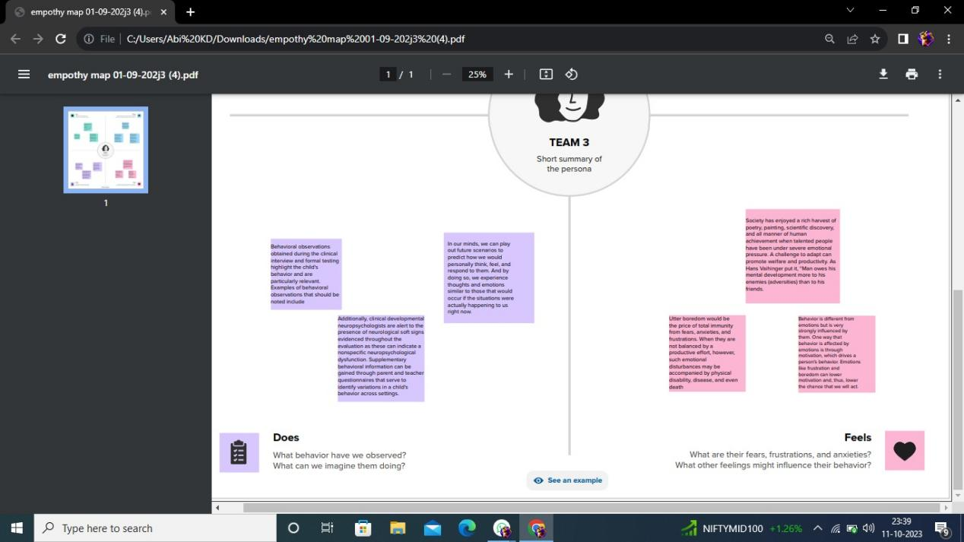

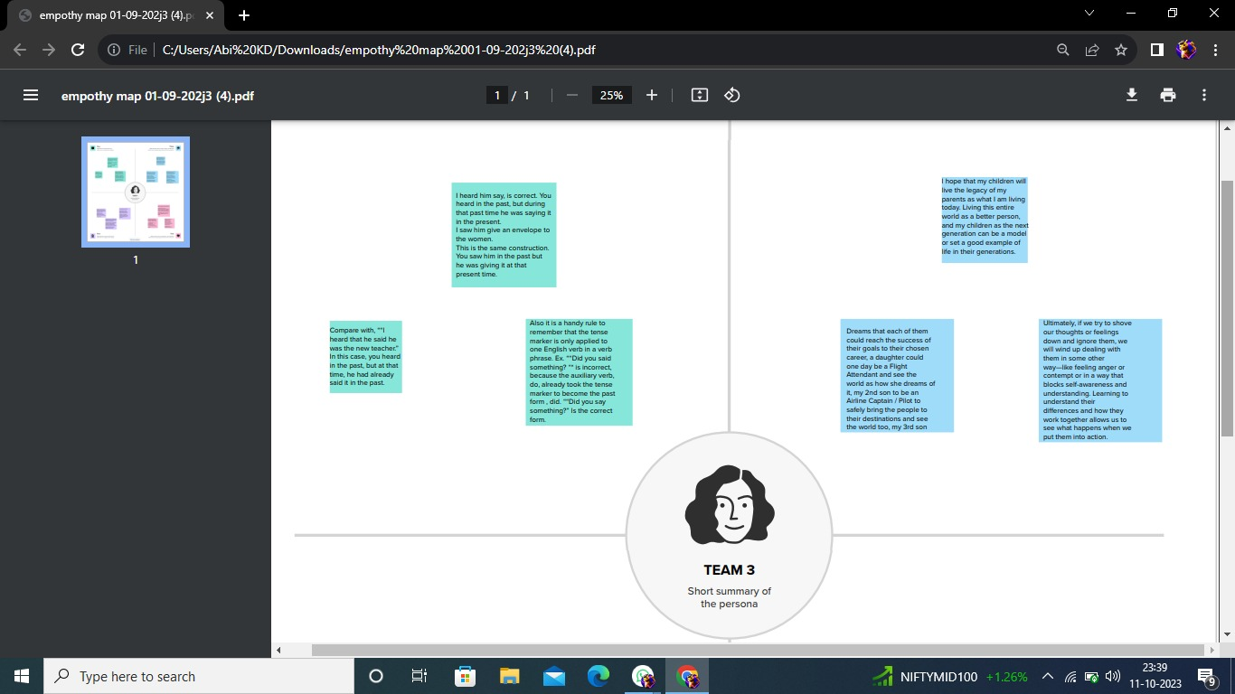

2.2 Ideation & Brainstorming Map

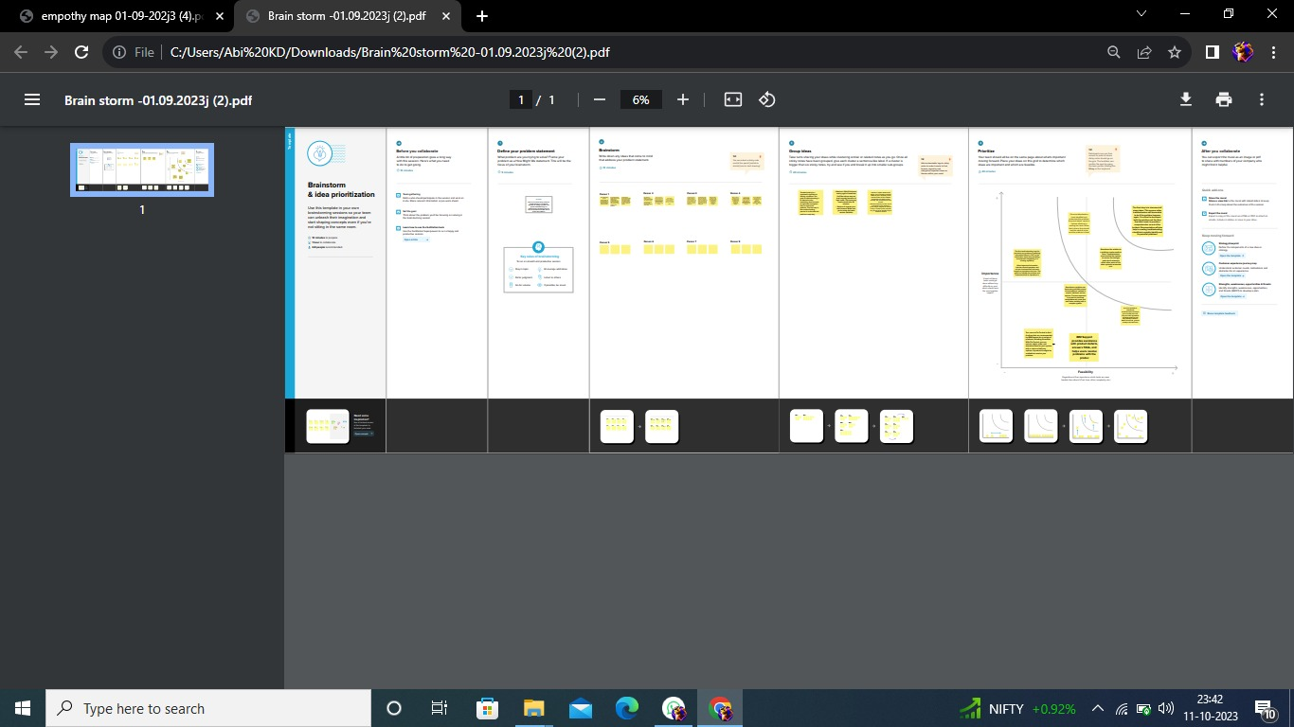

# 2.RESULT

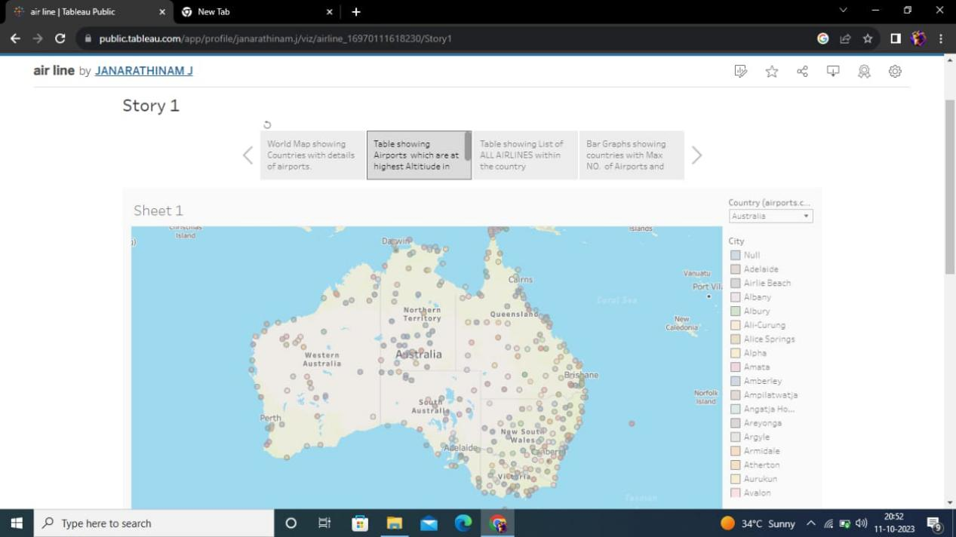

# 4.ADVANTAGES & DISADVANTAGES

## Advantages of Air Transport:

**Speed and Efficiency: One of the key advantages of air transport is its unparalleled speed. Airplanes can cover long distances in a matter of hours, enabling businesses to deliver goods quickly, especially for time-sensitive orders. This swift transportation option is particularly beneficial for industries such as e-commerce, pharmaceuticals, and perishable goods.**

### **Global Reach**

**Air transport provides extensive global coverage, connecting businesses to various destinations around the world. It allows companies to expand their customer base and reach new markets, irrespective of geographical barriers. This enables businesses to tap into international opportunities and access a broader range of customers.**

### **Reliable Timelines**

**Air transport operates on fixed schedules, ensuring reliable timelines for delivery. Airlines maintain strict adherence to departure and arrival times, minimizing delays and enhancing supply chain efficiency. This reliability is crucial for businesses that require precise order preparation and fulfillment to meet customer expectations.**

### **Reduced Inventory Holding Costs**

**The fast transit times offered by air transport help reduce inventory holding costs. With shorter lead times, businesses can maintain lower inventory levels while still meeting customer demands. This frees up working capital and minimizes storage expenses, contributing to overall cost savings.**

### **Enhanced Security**

**Air transport offers enhanced security measures compared to other modes of transportation. Airports have stringent security protocols in place to ensure the safety of cargo, including thorough screening processes and restricted access. This helps protect valuable and sensitive products during transit, reducing the risk of theft or damage.**

****You may also be interested in:****

* **[Drayage: The key to efficient logistics operations](https://www.ifssac.com/blog/en/drayage-the-key-to-efficient-logistics-operations/" \t "https://www.ifssac.com/blog/en/advantages-and-disadvantages-of-air-transport-everything-you-need-to-know/_blank)**
* **[From Frustration to Resolution Overcoming Cargo Claims Challenges](https://www.ifssac.com/blog/en/from-frustration-to-resolution-overcoming-cargo-claims-challenges/" \t "https://www.ifssac.com/blog/en/advantages-and-disadvantages-of-air-transport-everything-you-need-to-know/_blank)**
* **[What is the Difference Between a Freight Broker and a Dispatcher?](https://www.ifssac.com//blog/en/what-is-the-difference-between-a-freight-broker-and-a-dispatcher/" \t "https://www.ifssac.com/blog/en/advantages-and-disadvantages-of-air-transport-everything-you-need-to-know/_blank)**

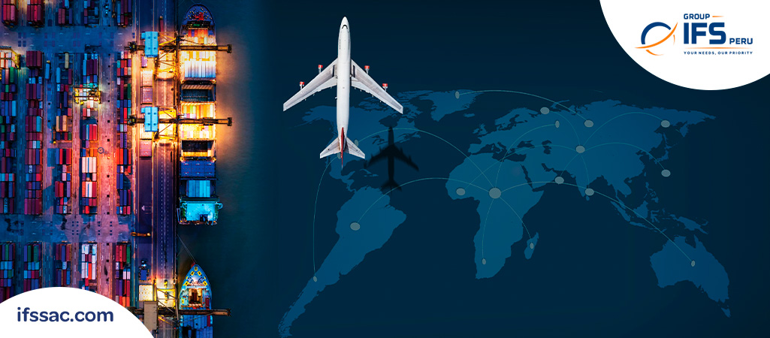

## **Disadvantages of Air Transport**

### **Higher Cost**

**One of the significant drawbacks of air transport is its higher cost compared to other modes, such as sea or land transport. Air freight charges are generally higher due to factors like fuel costs, infrastructure investments, and handling fees. Businesses must carefully evaluate the cost-benefit analysis of air transport based on their specific needs and budget.**

### **Limited Capacity**

**Airplanes have limited cargo space compared to ships or trains. This limited capacity can pose challenges for businesses dealing with bulky or oversized shipments. Air transport is best suited for high-value, time-sensitive goods that require swift delivery, rather than large-volume shipments.**

### **Restrictions on Hazardous Goods**

**Air transport has strict regulations regarding the transportation of hazardous goods. Certain hazardous materials or substances may be prohibited from being transported by air due to safety concerns. Businesses dealing with such goods need to comply with stringent regulations and find alternative transportation methods if necessary.**

**Understanding the advantages and disadvantages of air transport is crucial for businesses seeking efficient order preparation and global shipping solutions. The speed, global reach, reliable timelines, reduced inventory holding costs, and enhanced security make air transport an attractive option for many companies. However, it is essential to consider the higher cost and limited capacity associated with air transport.**

**For expert guidance and comprehensive logistics solutions, consider partnering with IFS [International Logistics Operator](https://www.ifssac.com/en" \t "https://www.ifssac.com/blog/en/advantages-and-disadvantages-of-air-transport-everything-you-need-to-know/_blank). With their extensive experience in air freight and supply chain management, they can provide tailored solutions to optimize your order preparation and ensure seamless transportation. Contact IFS International Logistics Operator today to discuss your logistics requirements and discover how they can enhance your supply chain operations.**

# 5.APPLICATIONS

**Air travel is a form of travel in vehicles such as airplanes, jet aircraft, helicopters, hot air balloons, blimps, gliders, hang gliders, parachutes, or anything else that can sustain flight.**

# 6.CONCLUSION

**This book addresses new technologies being considered by the Federal Aviation Administration (FAA) for screening airport passengers for concealed weapons and explosives. The FAA is supporting the development of promising new technologies that can reveal the presence not only of metal-based weapons as with current screening technologies, but also detect plastic explosives and other non-metallic threat materials and objects, and is concerned that these new technologies may not be appropriate for use in airports for other than technical reasons. This book presents discussion of the health, legal, and public acceptance issues that are likely to be raised regarding implementation of improvements in the current electromagnetic screening technologies, implementation of screening systems that detect traces of explosive materials on passengers, and implementation of systems that generate images of passengers beneath their clothes for analysis by human screeners.**

# 7.FUTURE SCOPE

**’First Europe, and then the globe, will be linked by flight, and nations so knit together that they will grow to be next-door neighbors. What railways have done for nations, airways will do for the world.’’**

**— Claude Grahame-White, 1914 (Aviation pioneer)**

**Airline industry has not just revolutionised the way we travel but has shrunk the world into few hours. Today, the airline industry carries a huge number of 3.6 Billion passengers per year and accounts for delivering one-third of the world’s trade. The growing numbers of passengers and the technological innovations have changed the face of the airline industry for good.**

**Let’s take a look at the top 10 emerging technologies which are revolutionising the flying experiences and digitally transforming it to a tech-savvy and customer centric industry.**

# **1. Blockchain Technology**

**Given the popularity gained by the blockchain technology in the financial sector it is seeing a wide range of applications in other industries as well. Airline industry has just started realising the potential of blockchain in various aspects. Recently, [Air France](https://futurism.com/one-of-the-worlds-largest-airlines-is-looking-into-blockchain-technology/" \t "https://robosoft.medium.com/_blank) talked about how they are looking at blockchain technology in improving business process and improving workflows.**

**Here is how airlines can use blockchain technology to improve operational efficiencies, security systems and even customer experiences**

* **By implementing blockchain technology airlines can do away with the need to rely on physical ID proofs by saving passengers’ data maintained in a virtual de-centralised database, which can be accessed by relevant people.**
* **It can help in turning flying miles into a more valuable asset which can be used to give added benefits to the customers, by tokenising these points and offering them a chance to accrue these points through a community of partners.**
* **Blockchain can be extremely useful in building a robust security system for managing customer data.**

# ****2. Augmented Reality and Virtual Reality****

**Industries like[retail,](https://www.robosoftin.com/blog/top-10-mobile-technology-trends-in-retail-industry/" \t "https://robosoft.medium.com/_blank)[healthcare](https://www.robosoftin.com/blog/digital-transformation-in-healthcare/" \t "https://robosoft.medium.com/_blank) etc. are seeing a lot of uses of the AR/VR revolution. Airlines industry is also following suit. Right now one of the most obvious applications of these technologies can be expected to be seen in the airport space where the airport experience can be enhanced with the help of AR/VR based apps. Foe e.g,**

* **The [Gatwick airport uses AR](https://www.vrfocus.com/2017/05/gatwick-uses-ar-to-help-passengers-navigate-the-airport/" \t "https://robosoft.medium.com/_blank) to help passengers navigate the complex layout of the airport, and London City Airport has installed AR tech to [help air traffic controllers](https://www.vrfocus.com/2017/05/london-city-airport-integrating-ar-for-air-traffic-control/" \t "https://robosoft.medium.com/_blank) with the vital job of keeping planes safe.**

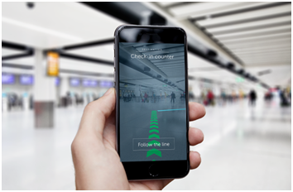

**Gatwick airport install navigation beacons that can interface with smartphones for AR navigation.**

# **3. Artificial Intelligence**

**With AI gaining traction industries are using it to upgrade customer experience at every touch point. From chat bots to voice-based AI tools there are umpteen use cases of AI being utilised.**

**The airline industry understands the power of AI in helping them stepping up their technology game. A lot of forward thinking airlines understand the impact AI can have in multiple areas of the industry and are already investing in the same.**

**E.g. [UK-based EasyJet](https://www.mercator.com/blog/its-time-for-airlines-to-take-data-science-and-artificial-intelligence-seriously?__hstc=148631400.2f92c8caa5ebcabeb75dda8fc589870b.1509357734964.1509357734964.1509357734964.1&__hssc=148631400.1.1509357734964&__hsfp=3087073821" \t "https://robosoft.medium.com/_blank) is using AI for predictive analysis. The airline is using a combination of these technologies to make sense of all the available data and use these insights to create offers and services personalised for individual travellers. The airline also has a recognition tool that reads passports and fills out all the information for flyers — easing out the data entry and data management tasks more manageable.**

**Easy jet, Korean Air is also exploring how voice-activated digital assistant can help in offering a seamless travel experience.**

# **4. Beacons technology**

**Beacons technology has seen a lot of success when it comes to retail and there is a huge potential for the airline industry to use Beacons in making navigation easy for travellers between different terminals at the airport. Further, Beacons can help airports and vendors at the airport premises to know where passengers are and then send them personalised and relevant information accordingly. These updates can be about boarding gate number, baggage carousel, flight status or also about the shops and eateries around the customer.**

**MIAMI International airport is already leveraging Beacons in its premises to create a personalised experience for the travellers. The app provides information about the entire airport as travellers navigate through various places at the premises. Further, they are also updated with relevant information depending on their individual journey, e.g. gate numbers, flight updates, baggage collection details, etc.**

# ****5. Robotics****

**The airline industry is also using robotics in assisting with various tasks like customer management, baggage handling, car parking, etc.**

**The introduction of KLM’s [socially-aware ‘Spencer Robot’](http://www.futuretravelexperience.com/2016/04/socially-aware-spencer-robot-guides-passengers-at-schiphol/" \t "https://robosoft.medium.com/_blank) last year created a lot of buzz. This robot has been equipped with the capability to deal with social situations between people and can ‘see’ and analyse people nearby with his sensors. Spencer can also distinguish between individuals, families and larger groups, and also learns about and then complies with social rules, ultimately acting in a human-friendly way.**

# ****6. Biometrics****

**The airlines industry is consistently working towards making travel experience delightful and comfortable for their customers. Adopting the Biometrics Technology at airlines and airport touch points is one such attempt by the industry. Back in 2015, the biometrics trial was launched with the ‘Happy Flow’ project. Aptly named, this project aimed at creating a seamless and secure air travel process.**

**In just two years, today, a lot of biometric-enables single token platforms have been introduced, and airlines and airports are leveraging them to revolutionise passenger experiences. E.g.[Air New Zealand has launched a biometric-enabled bag drop](https://www.airnewzealand.com.au/press-release-2015-air-new-zealand-introduces-world-first-biometric-bag-drop" \t "https://robosoft.medium.com/_blank) to speed-up the check-in process.**

**Recently Delta Airlines went a step ahead and launched the world’s first self-service biometric-enabled baggage drop to free up “free up more Delta people” to deal with customers.**

# ****7. Wearable technology****

**Airlines have started to use wearable technology is various ways to do more than improving customer experience on flights. Some of the examples of airlines using wearable technology are:**

**- Recently Japan Airlines used Microsoft’s HoloLens for training its new crew members and engineers. Using HoloLens, the mechanics can be trained about engine mechanics akin to the experience they will have working on an actual plane.**

**- Easy Jet and British Airways are among the airlines that have created apps for the [Apple Watch](http://www.apple.com/watch/" \t "https://robosoft.medium.com/_blank), enabling passengers to store boarding passes and receive real-time updates on their wrist.**

# ****8. Internet of Things****

**According to the[FTE](http://www.futuretravelexperience.com/wp-content/uploads/think-tanks/connectivity-2025-think-tank.pdf" \t "https://robosoft.medium.com/_blank):**

**‘’Over the course of the next decade, it is likely that all “things” on board will be connected and the health of everything, from engine performance to the IFE system, will be monitored in real-time. Sensors will automatically detect and report faults to maintenance teams on the ground, removing the need for the crew to manually report faults. Moreover, the addition of sensors to aircraft seats will enable the crew to monitor individual passenger health and wellbeing, and to proactively respond to their needs.’’**

**Virgin Airlines have implemented IoT in its Boeing 787. Every single element on the plane is attached to a wireless aeroplane network, providing real-time IoT data on elements like performance, maintenance etc. The airline is using the deluge of data that it is collecting through these flights to improve the efficiency of the aircraft and also being pro-active.**

# **9. **Big Data and Analytics****

**Airlines can drive valuable insights by analysing the vast amount of data available to them to create delightful experiences for travellers, understand customer preferences in real-time based on data of their purchase history, travel itineraries etc. and provide them customised offers etc.**

**E.g. United Airlines uses a smart ‘’collect, detect, act’’ system to analyse around 150 variables in the customer profile including their previous purchases, preferences etc. and provide tailor-made offers to them. United Airlines has seen a YoY revenue increase of 15% after implementation of this system.**

**Further, this data can also help in increasing the operational efficiencies through predictive analytics.**

**Southwest Airlines has [partnered with NASA](https://www.nasa.gov/connect/chat/data_mining_chat.html?utm_source=datafloq&utm_medium=ref&utm_campaign=datafloq" \l ".V2NAcbsrKUk" \t "https://robosoft.medium.com/_blank) to indicate potential safety issues. By using machine-learning algorithms, they have built an automated system capable of crunching vast data sets to warn about anomalies and to prevent potential accidents.**

# **10. **Mobile solutions****

**Today, smartphones have become an integral part of people’s life. Airlines have started venturing into the world of mobile solutions and are using this platform to connect with their customers throughout the passenger journey starting from booking of a flight till deplaning it.**

**E.g. Delta Airlines recently started providing their passengers’ virtual boarding passes 24 hours before their journey through their mobile app, easing out the check-in process for their passengers.**

**In our article, we take a detailed look at [how Airlines are using the mobile platform to create delightful customer experiences.](https://www.robosoftin.com/blog/technology-in-airline-industry/" \t "https://robosoft.medium.com/_blank)**

**Digital technologies are changing the landscape of every industry and the digital revolution in the airline industry has just begun. In times to come the airline travel experiences are set to become more personalised, valuable and technologically enhanced building memorable flying experiences for the customers.**

# 8.APPENDIX

**https://public.tableau.com/app/profile/janarathinam.j/viz/airline_16970111618230/Story1?publish=yes**